Experiment 31:
Aim:
31.Write a Python program to create a stacked bar plot with error bars.
Python code:
import matplotlib.pyplot as plt
import numpy as np

# Data
labels = ['G1', 'G2', 'G3', 'G4', 'G5']
men_means = [20, 35, 30, 35, 27]
women_means = [25, 32, 34, 20, 25]
men_std = [2, 3, 4, 1, 2]
women_std = [3, 5, 2, 3, 3]

width = 0.35

# Create stacked bar chart with error bars
fig, ax = plt.subplots()
ax.bar(labels, men_means, width, yerr=men_std, label='Men', color='skyblue')
ax.bar(labels, women_means, width, bottom=men_means, yerr=women_std, label='Women', color='salmon')

# Add labels and title
ax.set_ylabel('Scores')
ax.set_title('Scores by group and gender')
ax.legend()

plt.show()

Output:
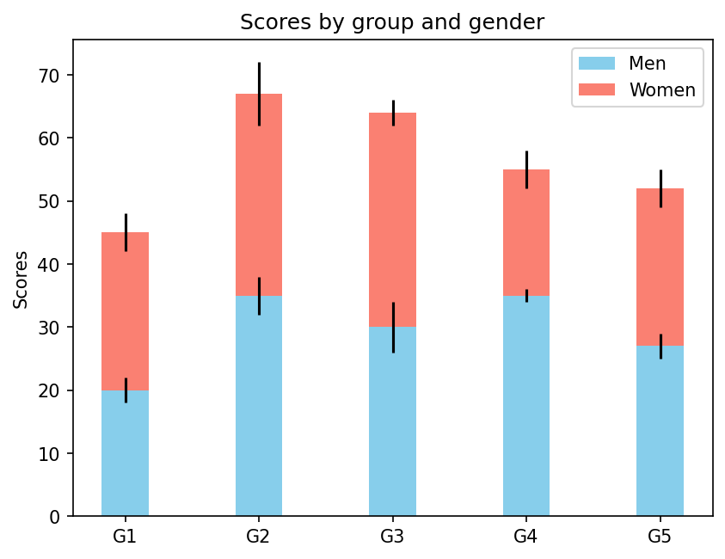
Experiment 32:
Aim:
32.Write a Python program to draw a scatter graph taking a random distribution in X and Y and plotted against each other.
Python code:
import matplotlib.pyplot as plt
import numpy as np

# Data
x = np.random.rand(100)
y = np.random.rand(100)

# Create scatter graph
plt.scatter(x, y, color='skyblue')

# Add labels and title
plt.xlabel('X values')
plt.ylabel('Y values')
plt.title('Scatter Graph of Random Distribution')

plt.show()

Output:
